* 已经先创建了员工信息表: emp, dept, bonus, salgrade

多表查询

- 等值连接
@ 等值连接可以互通: 查询员工信息包括部门名称.
mysql> select e.empno, e.ename, e.sal, d.deptno, d.name
-> from emp e, dept d
-> where e.deptno = d.deptno;
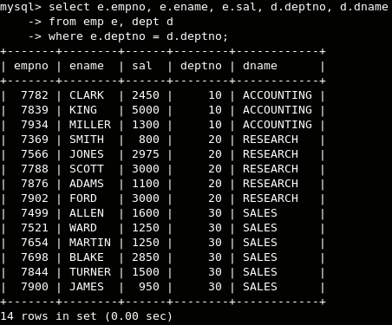

- 不等值连接
@ 不等值连接可以互通: 查询员工薪水等级

mysql> select e.empno, e.ename, e.sal, s.grade
-> from emp e, salgrade s
-> where e.sal between s.losal and s.hisal ;
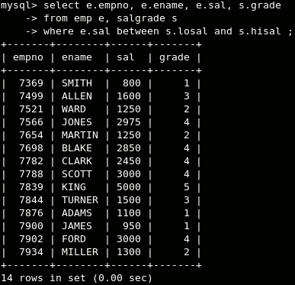

mysql> select e.empno, e.ename, e.sal, s.grade
-> from emp e, salgrade s
-> where e.sal > s.losal and e.sal < s.hisal;
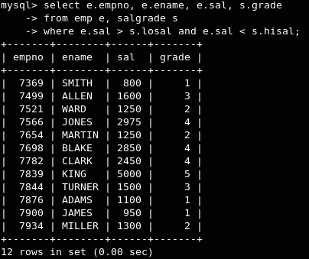

- 外连接
@ 按部门统计员工人数: 部门号, 部门名称, 部门人数.
思路1: 因为部门人数要从emp表中检索, 需要多表查询
思路2: 各部门人数需要分组

- 简单外连接: 支持
mysql> select d.deptno, d.dname, count(e.empno)
-> from dept d, emp e
-> where d.deptno = e.deptno
-> group by d.deptno, d.dname
-> ;
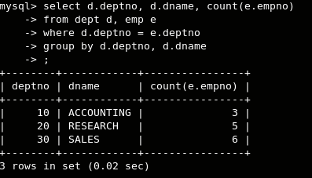

- 左/右外连接: 不支持
*不满足条件的40号部门没有显示(没有40号部门), 但仍然要显示.

mysql> select d.deptno, d.dname, count(e.empno)
-> from dept d, emp e
-> where d.deptno = e.deptno (+)
-> group by d.deptno, d.dname ;
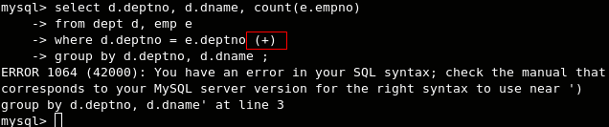

@ MySQL自己的语法: 可以省略outer关键字

- 左外连接: 左外连接
mysql> select d.deptno, d.dname, count(e.empno)
-> from dept d Left outer join emp e
-> on d.deptno = e.deptno
-> group by d.deptno, d.dname ;
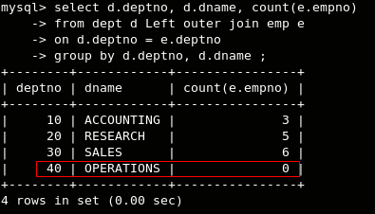
mysql> select d.deptno, d.dname, count(e.empno)
-> from dept d LEFT outer join emp e //与这个顺序有关
-> on e.deptno = d.deptno //与这个顺序无关
-> group by d.deptno, d.dname;
*结果一样!

mysql> select d.deptno, d.dname, count(e.empno)
-> from dept d RIGHT outer join emp e //这时候是emp的deptno
-> on e.deptno = d.deptno
-> group by d.deptno, d.dname;
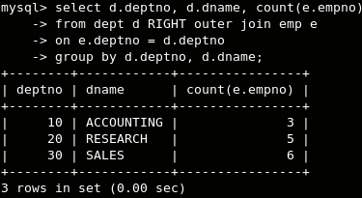

- 右外连接: 右边有值才显示.

mysql> select d.deptno, d.dname, count(e.empno)
-> from emp e RIGHT OUTER JOIN dept d
-> on e.deptno = d.deptno
-> group by d.deptno, d.dname;
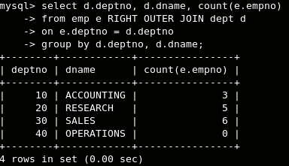

- 满外连接: 任一边有值就会显示.
mysql> select e.*, d.*
-> from emp e
-> FULL outer join dept d
-> on e.deptno = d.deptno ;

- 4 交叉连接: 交集, 即笛卡尔积
mysql> select e.*, d.*
-> from emp e
-> cross join dept d;

- 自连接
@ 查询员工的上级
- 正常连接, 没有显示全部员工 (共14个)
mysql> select e.ename, b.ename
-> from emp e, emp b
-> where e.mgr = b.empno;
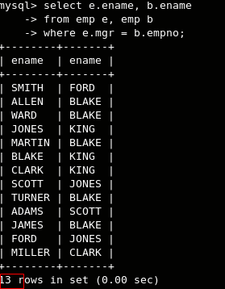

- 外连接显示全部:
mysql> select e.ename, b.ename
-> from emp e Left outer join emp b
-> on e.mgr = b.empno;
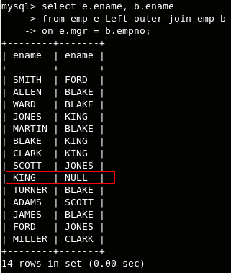

- 连接字符, 并滤空.
@ Oracle的字符在MySQL中不支持: ||
mysql> select 'douBi' || 'shi ni' from dual;
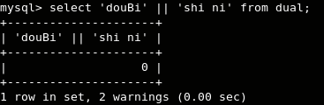
* 可以用concat()函数:
mysql> select concat(1314, 'Love');
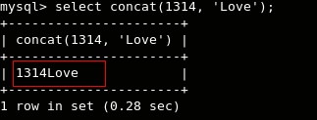

@ 连接并滤空
* 滤空函数MySQL也不支持Oracle的nvl(), 有自己的ifnull()
mysql> select concat(e.ename, '\'s HIGHER-UP IS ',ifnull(b.ename, 'Himself !'))
-> from emp e Left Outer Join emp b
-> on e.mgr = b.empno;
